**CLOUD BASED CONTAINMENT ZONE ALERTING APPLICATION**

**ABSTRACT:**

The recent outbreak of COVID-19 has taken the world by surprise, forcing lockdowns and straining public health care systems. COVID-19 is known to be a highly infectious virus, and infected individuals do not initially exhibit symptoms, while some remain asymptomatic. Thus, a non-negligible fraction of the population can, at any given time, be a hidden source of transmissions. In response, many governments have shown great interest in smartphone contact tracing apps that help automate the difficult task of tracing all recent contacts of newly identified infected individuals. However, tracing apps have generated much discussion around their key attributes, including system architecture, data management, privacy, security, proximity estimation, and attack vulnerability. In this article, we provide the first comprehensive review of these much-discussed tracing app attributes. We also present an overview of many proposed tracing app examples, some of which have been deployed countrywide, and discuss the concerns users have reported regarding their usage. We close by outlining potential research directions for next-generation app design, which would facilitate improved tracing and security performance, as well as wide adoption by the population at large.

**LITERATURE SURVEY:**

A literature review surveys books, scholarly articles, and any other sources relevant to a particular issue, area of research, or theory, and by so doing, provides a description, summary, and critical evaluation of these works in relation to the research problem being investigated. This application is intended to provide information about containment zones in a particular region by alerting people, through continuous monitoring of an individual's location. Key benefits of the application are monitoring people's activity and alerting them of their safety movements.

**SYSTEM ARCHITECTURE:**

The type of architecture adopted for the data collection aspects of tracing apps has been a matter of much discussion due to both security and privacy concerns. We will discuss three distinct system architectures commonly used or proposed for developing COVID-19 tracing applications. These are the centralised, the decentralised, and the hybrid approaches that combine features from both the centralised and the decentralised architectures. Our classification criteria consider how the server is used and what data is required (or stored) by it. We now discuss each of the three architectures detailing their salient features. We will discuss some specific tracing apps that employ each of our three architectures in a later section.

**ARCHITECTURE DESIGN :**

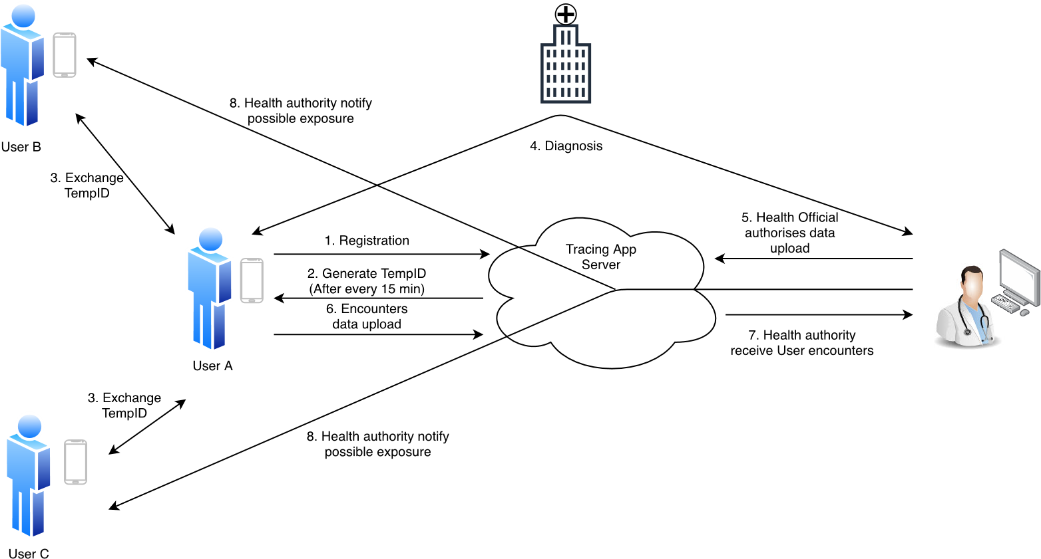

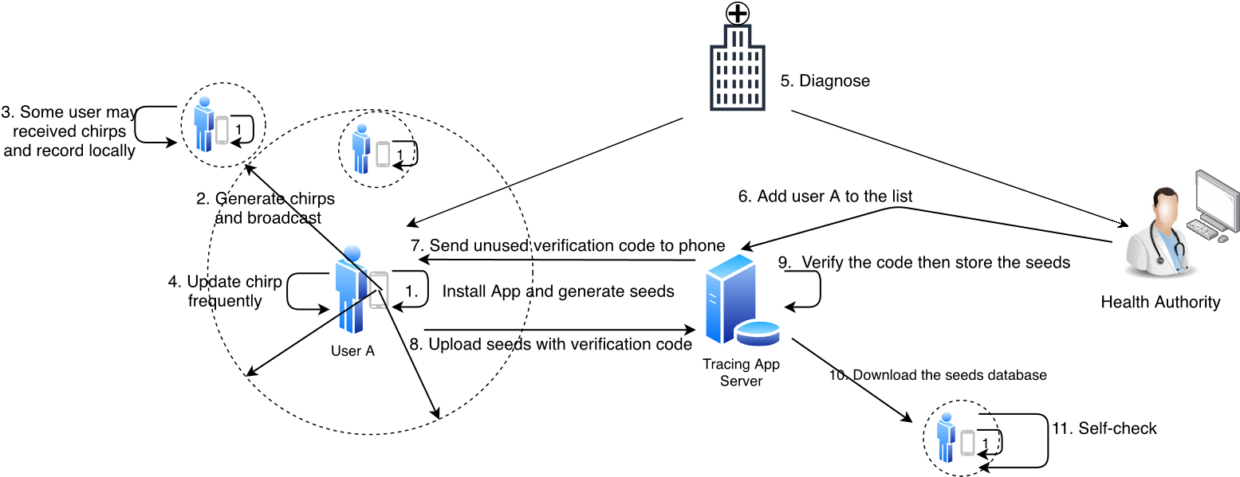

**CONCLUSION:**

The COVID-19 pandemic continues to affect the way of life of everyone. The contact tracing apps are likely to play a vital role in aiding health authorities quickly identify individuals that may have been exposed to the virus. The imminent interest and adoption of tracing app technology will improve the tracing capability of health authorities; however, as this article highlighted, it is not a silver bullet. These apps still face many concerns from users, data protection agencies, and researchers. The main concerns are related to the user data management, potentially non-trivial false positive and negative instances, and the security and privacy issues of these apps. Guided by these concerns, this article presented an overview of the three common tracing app architectures: centralised, decentralised, and hybrid; and an overview of popular apps within these categories. Additionally, the paper focused on the privacy and security aspects, mapping attacks that could be possibly performed in each of the three architectures. This article also elucidates some other users’ concerns regarding battery drain, compatibility, consent withdrawal, and transparency. Finally, we discussed some of the near and long term future research directions.

**REFERENCE:**

1. **.** P. H. O’Neill, T. Ryan-Mosley, and B. Johnson. (2020). *A Flood of Coronavirus Apps are Tracking Us. Now it’s Time to Keep Track of*

*Them*. [Online]. Available: https://www.technologyreview.com/2020/05/ 07/1000961/launching-mittr-cov%id-tracing-tracker/

1. **.** S. Vaudenay, ‘‘Centralized or decentralized? The contact tracing dilemma,’’ *IACR Cryptol. ePrint Arch.*, vol. 2020, p. 531, May 2020.

[Online]. Available: <https://eprint.iacr.org/2020/531>

1. **.** C. Criddle and L. Kelion. (2020). *Coronavirus Contact-Tracing: World Split Between Two Types of App*. [Online]. Available: https://www.bbc. com/news/technology-52355028
2. **.** J. Duball. (2020). *Centralized vs. Decentralized: EU’s Contact Tracing Privacy Conundrum*. [Online]. Available: https://iapp.org/news/a/ centralized-vs-decentralized-eus-contact-tracin%g-privacy-conundrum
3. **.** R. Jennings. (2020).*What are the Data Privacy Considerations of Contact Tracing Apps*. [Online]. Available: https://ukhumanrightsblog. com/2020/05/01/what-are-the-data-privacy-cons%iderations-of-contacttracing-apps/
4. **.** D. Palmer. (2020). *Security Experts Warn: Don’t Let Contact-Tracing App Lead to Surveillance*. [Online]. Available: https://www.zdnet.com/ article/security-experts-warn-dont-let-contact-tr%acing-app-lead-tosurveillance/